Software Requirements Specification

For

<*Online Group Discussion Forum*>

**Version 1.0 approved**

**Table of Contents**

**Table of Contents ii**

**1. Introduction 1**

1.1 Purpose 1

1.2 Document Conventions 1

1.3 Intended Audience and Reading Suggestions 1

1.4 Product Scope 1

1.5 References 1

**2. Overall Description 2**

2.1 Product Perspective 2

2.2 Product Functions 2

2.3 User Classes and Characteristics 2

2.4 Operating Environment 2

2.5 Design and Implementation Constraints 2

2.6 User Documentation 2

2.7 Assumptions and Dependencies 3

**3. External Interface Requirements 3**

3.1 User Interfaces 3

3.2 Hardware Interfaces 3

3.3 Software Interfaces 3

3.4 Communications Interfaces 3

**4. System Features 4**

4.1 System Feature 1 4

4.2 System Feature 2 (and so on) 4

**5. Other Nonfunctional Requirements 4**

5.1 Performance Requirements 4

5.2 Safety Requirements 5

5.3 Security Requirements 5

5.4 Software Quality Attributes 5

5.5 Business Rules 5

**6. Other Requirements 5**

**Appendix A: Glossary 5**

**Appendix B: Analysis Models 5**

**Appendix C: To Be Determined List** 6

# Introduction

## Purpose

## The main aim of online group discussion forum is to create an interactive platform where students can collaborate, share ideas and engage in discussions with their peers and teachers. The admin can also use the system to monitor and moderate the discussions, provide feedback, and make announcements.

## 1.2 Document Conventions

Discussion Forum: Online discussion forum with a platform for questions and answers for BIT students.

Admin: The head of each department in this system.

Blogs: Educational resources for students.

Future activities: Activities held at the Institute, such as coding competitions and technical activities.

Trending Tags: Discussion Forum Trending Questions.

## 1.3 Intended Audience and Reading Suggestions

The intended audience who will be mainly using our system are:

Admin, Faculty, Students

* Admin will register using their email and password will monitor and moderate discussions and students profile, take actions against inappropriate content, make announcements.
* Faculty will Create a new discussion topic, provide answers to questions, post comments on an existing discussion topic, edit and delete their own posts and will moderate discussions and delete inappropriate content.
* Students will log in /register using their email and password*,* Post questions and give answers, receive feedback, find previously answered questions with the help of tags, and able to view trending questions and upcoming events.

## 1.4 Product Scope

* Create an open and collaborative environment where members can exchange ideas and learn from each other.
* A platform for members to share their thoughts and opinions, and to ask questions and receive feedback from others.
* Discussion Forum provides a space for members to share resources, such as links to articles, videos, and other materials.
* All the stakeholders will have the facility to ask questions on the forum and get the desired response.
* The user can also find previously answered questions with the help of tags.
* Weekly Blogs, Activities or events will be posted by admin and moderator for  guiding students.

## References

* Gwo-Jen Hwang, Effectiveness of Using Online Discussion Forum, Volume 2014, Article ID 589860, <https://www.hindawi.com/journals/edri/2014/589860/>, 26 May 2014
* A Design-Based Study for Development of a Model for a Successful Online Discussion Forum, Volume 17, Issue 1, <https://www.igi-global.com/gateway/article/full-text-pdf/294574>
* Alzahrani, M. G. (2017). The effect of using online discussion forums on students’ learning. TOJET: The Turkish Online Journal of Educational Technology, 16(1), 164–176. doi:10.5430/wje.v7n2p
* Promoting college students’ systems thinking in asynchronous discussions: Encouraging students initiating questions, Volume 13 – 2022,

[https://www.frontiersin.org/articles/10.3389/fpsyg.2022.1028655/full#ref8](https://www.frontiersin.org/articles/10.3389/fpsyg.2022.1028655/full), 13 Dec 2022

* Stephanie J. Blackmon, Outcomes of Chat and Discussion Board Use in Online Learning: A Research Synthesis, University of Alabama, <https://files.eric.ed.gov/fulltext/EJ985399.pdf>,2012

# Overall Description

## Product Perspective

A discussion forum is a web-based application which provides a medium to share knowledge with the world about what you’ve learned from your own studies and experiences. Discussion forum helps to emphasize important concepts covered in a particular module or to elaborate on a topic that the course lecture or readings didn’t cover in depth. It allows users to share their thoughts and opinions, ask questions, and gain insights from other members of the forum. It is a great way for people to connect and learn from one another. They can also be used to facilitate debates and discussions, allowing people to think critically and share their perspectives.

The goal of this system is to allow users to connect with each other online and to provide new users with discussion services. A registered user can create new posts and respond to existing ones.

## Product Functions

Main Functionalities of this Discussion Forum are:

* Providing a platform where users can create and participate in group discussions on various topics related to their courses or other areas of interest.
* Allowing users to create and manage their profiles, including their personal information, interests, and academic history.
* The platform includes reporting and moderation features to help maintain a safe and respectful environment for users. Admin can delete any inappropriate content or behavior, and can review and take action on reported content.
* The platform includes a search functionality that allows users to find specific discussions, tags or posts quickly.
* Trending tags will be visible where the users can search for any question with the help for those tags.

## 2.3 User Classes and Characteristics

## 

Fig 2.3 Use Case Diagram

## 2.4 Operating Environment

Our website can smoothly work on both windows and mac-os operating systems.

## 2.5 Design and Implementation Constraints

Since the entire website is in only one language i.e English it might be difficult for other people speaking different languages.

## 2.6 Assumptions and Dependencies

Assumptions:

* The users have access to a reliable internet connection to use the platform.
* The users will be able to receive timely support and assistance from the platform administrators in case of any issues or queries.

Dependencies:

* The platform will require regular updates and maintenance to keep up with changing technology and user needs.
* The platform's success will depend on the level of user adoption and engagement.

# External Interface Requirements

## User Interfaces

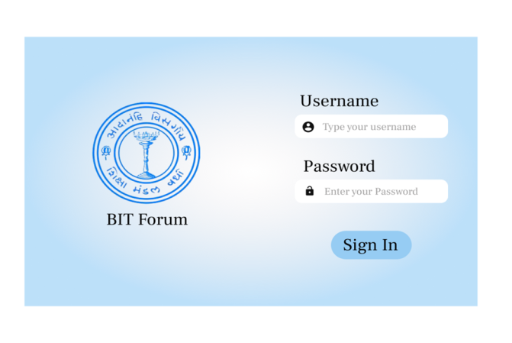 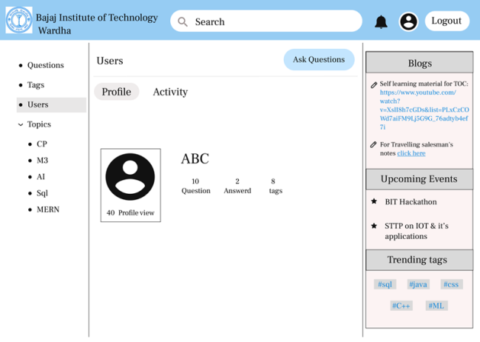

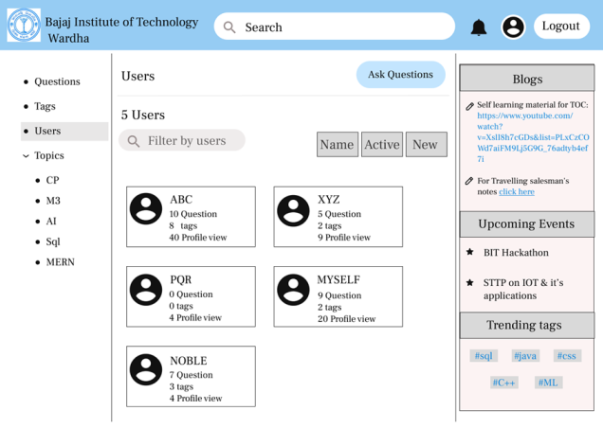 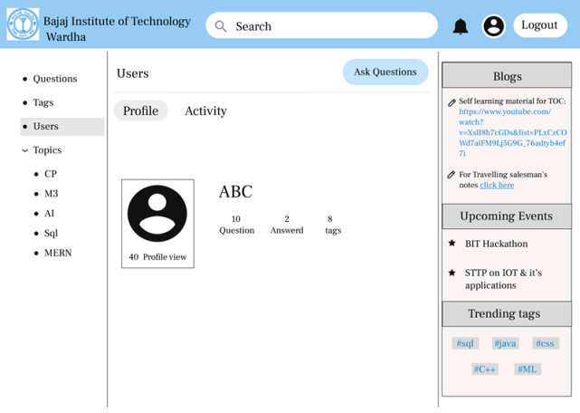

## 3.2 Hardware Interfaces

* Windows
* A browser which supports HTML, Firebase.

## Software Interfaces

The user’s browser should be HTML5 compatible for a satisfactory user experience.

## 3.4 Communications Interfaces

The discussion forum shall use the HTTP protocol for communication over the internet.

# System Features

The section illustrates the functional requirements for the product and the major services provided by the product.

## Functional Requirement

REQ-1:  Authenticate and Login user to the discussion forum.

REQ-2:  New users can register in the forum.

REQ-3:  A registered user is able to view his profile. Additional information viz. questions asked by him and answers posted by him are also displayed.

REQ-4:  Users can view questions and their corresponding answers.

REQ-5:  A logged in user can ask questions.

REQ-6:  A logged in user can post answers to any questions.

REQ-7: Provide an interface for the admin to approve posts so that posts are not visible without admin approval

REQ-8: To enable a logged in user to upvote and downvote answers.

REQ-9:  Users can search questions with the help of tags.

REQ-10: Users get to know about upcoming events, trending tags and can also view weekly blogs.

REQ-11: Admin will have authority to manage and monitor every matter happening in the discussion forum.

# Other Nonfunctional Requirements

## Performance Requirements

* The system must be interactive and the delays involved must be less .
* Smooth working of discussion forum is must to ensure good user interactions.
* Server will be working 24X7.

## Safety and Security Requirements

* Only the users(students, faculties and staff) who are registered within the institute can login to the discussion forum
* Information transmission should be securely transmitted to server without any changes in information

## 5.3 Security Requirements

* Access to unauthorized users would be prevented.
* The system enables only a logged in user to ask questions and  post answers.
* The content authorized by the admin can only be posted on the discussion forum.

## 5.4 Software Quality Attributes

* As the system is easy to handle and navigates in expected way with no delays.
* The system functions accordingly and transverses quickly between its states.
* For security concern of users account, a proper login mechanism is used to avoid   hacking.
* The System is user friendly.

# Other Requirements

Appendix A: Glossary

Discussion Forum: Online Discussion Forum i.e Question and Answer Platform for the students of BIT

Admin: In this system, the HOD of each department.

Blogs: Learning Material for students.

Upcoming Events: The events held in the Institute like (Coding Contests, Technical events etc. )

Trending Tags: Trending Questions on Discussion Forum.

Appendix B: Analysis Models

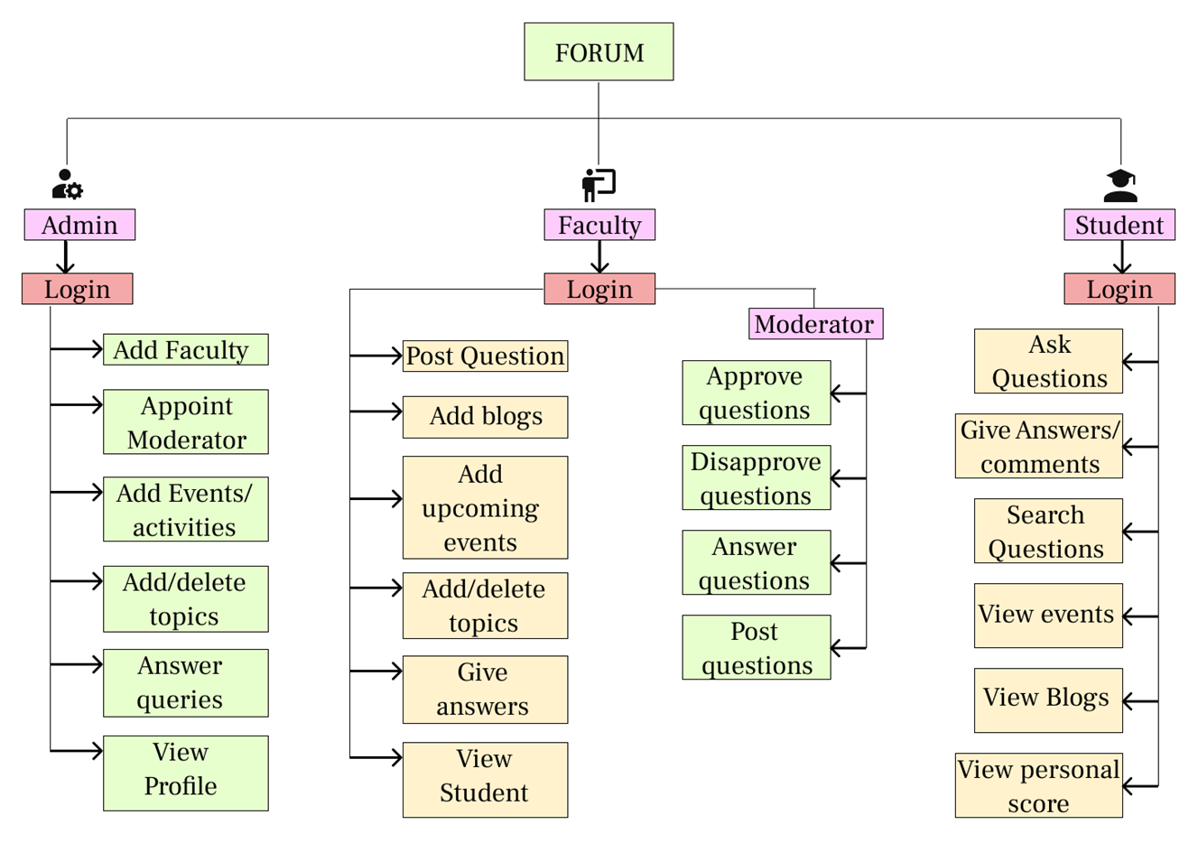

Process Flow

